# Comp3000 final year project GDD

## 

**Comp3000 final year project GDD** **1**

Problem Domain 2

Study of similar products on the market 2

Gris 3

Night in the Woods 3

Headspace 4

CBT Companion 5

Project Description 6

**Characters** **6**

Player character 7

NPCs 8

Story 8

Setting 8

The Map 9

Theme 9

**Story Progression** **9**

Game Opening 9

The main game 10

Ending 10

Goals 10

Short Term Goals 10

Long Term Goals 10

User Skills 10

Game Mechanics 11

Items and Power Ups 11

Progression and Challenge 11

Losing 11

**Art Style** **11**

Modelling 11

**Music and Sounds** **12**

**Technical Description** **13**

**Marketing** **13**

Demographics 13

Platforms and Monetisation 13

Localisation 13

**Other Ideas** **13**

## 

## Problem Domain

Many people would benefit from learning healthy habits and practices that improve their wellbeing, but people aren't given the opportunity to learn these skills until they reach a crisis point and need to seek help. It can be overwhelming and time consuming to start looking into psychology and mental health maintenance as an individual, which may dissuade people from making it a priority in their life.

Media can be a powerful tool to influence audiences priorities, interests, and opinions. Games as a medium can be a very successful educational tool, teaching people through play. Both games and media as a whole are likely to be more appealing to an individual than a self-help section of a bookshop. By researching how media affects audiences, I will make a game which aims to not only provide an enjoyable experience and escapism, but also to inspire better self care practices in users.

Exploring problem domain <https://coggle.it/diagram/YWWL8P-qSQOj-HqP/t/-/defa968930c308a79253876ca9e06adc2659b30697014c80cb9b9b7e09cf79a1>

* Narrative game with a focus on wellbeing and learning self care practices.
* Inspired by the wholesome games movement.
* Informed by research about how media can affect audiences to change their own lives.
* Should have basic controls, more accessible to people who aren’t avid gamers.

### Study of similar products on the market

Considering similar games and applications for wellbeing, seeing what makes them successful, and what attributes from them I can take or leave when it comes to my own project. Asking the questions:

What is the product?

How does it aim to help users?

How do users interact with the product?

What makes it a good example of this type of product?

What parts of this will I keep?  
How will my game be distinct, offer something new?

#### Gris

| What is the product? | **Gris**, a game from indie developer [Nomada Studios](https://nomada.studio/), explores the emotional experience of traversing the trials and tribulations of grief through a beautifully designed, watercolour-style, puzzle platformer. |
| --- | --- |
| How does it aim to help users? | Gris a character going through grief that they can relate to, offering emotional support and understanding. |
| How do users interact with the product? | Playing through the world. It’s a puzzle platformer, so players move their character around the world and see it open up and fill with colour as they move through their grief. |
| What makes it a good example of this type of product? | Gris communicates a complex, emotive story with symbolism rather than dialogue.  It’s been received well by audiences, selling over a million copies and winning multiple awards.  The approach to grief is informed by psychologists, especially the concept of the 5 stages of grief. |
| What parts of this will I keep? | I will also create story progression and goals inspired by psychology and informed by research.  I’ll look into how I can enhance my story with visuals, especially how game mechanics and colour are utilised. |
| How will my product be different? | My game will have multiple characters to interact with, so more of the storytelling will be done through dialogue.  Rather than capturing one specific experience, like Gris does with grief, my project will focus on general feelings of anxiety and depression. |

#### 

#### Night in the Woods

| What is the product? | **Night in the Woods** is an adventure game focused on exploration, story, and character, featuring dozens of characters to meet and lots to do across a lush, vibrant world. The themes addressed include mental illness, depression, the stagnancy of the middle and lower classes, and the slow death of small town America. |
| --- | --- |
| How does it aim to help users? | The main purpose of this game is entertainment - it shows a character struggling with some mental health issues, but it is not the main purpose of the game or the reason to play it. People choose to play it to have fun, and while they’re at it, may feel comforted and seen by the depictions of depression. |
| How do users interact with the product? | Users play as Mae, a college dropout returning home and reconnecting with other people and filling her days. Gameplay is very basic platforming, dialogue with other characters, and mini games. |
| What makes it a good example of this type of product? | It depicts mental health accurately, as something that multiple characters deal with but which doesn’t define them. Minigames offer a break in the stress and dark world for both the main character and the player. The story and the main characters' experience is affected by who players choose to interact with more. There’s no right or wrong way to play. |
| What parts of this will I keep? | Character driven. Player choices influence the story without changing the overall direction of the game. |
| How will my product be different? | My product will be a slightly more hopeful take - rather than simply normalising and representing mental illness, I’ll focus on showing different coping mechanisms and representing characters grow and improve their wellbeing. |

#### 

#### Headspace

| What is the product? | **Headspace** provides [guided meditation](https://en.wikipedia.org/wiki/Guided_meditation) resources online, accessible to users through the company's website and via a mobile app on the iPhone and Android platforms. |
| --- | --- |
| How does it aim to help users? | Headspace teaches mindfulness to help cope improve mental health and wellbeing. |
| How do users interact with the product? |  |
| What makes it a good example of this type of product? | It’s proven to be effective - studies have found a significant increase in wellbeing, reductions in anxiety and depressive symptoms, significant reductions in diastolic blood pressures, significant increases in perceived job control, as well as a significant reduction in sleeping problems. |
| What parts of this will I keep? | Informed by science and psychology, easy to dip in and out of for short periods of time. |
| How will my product be different? | My product will provide entertainment as well as support, and aim to teach good habits which can be used outside of the product. |

#### 

#### CBT Companion

| What is the product? | **CBT Companion** is a companion app to learn and practise Cognitive Behavior Therapy (CBT) Techniques. |
| --- | --- |
| How does it aim to help users? | Teach users CBT and provide an environment for them to practise it in. |
| How do users interact with the product? |  |
| What makes it a good example of this type of product? | Focused on one specific approach to treating mental illness. Makes a proven form of therapy, CBT, more readily available and accessible to users so they don’t have to wait until they hit a crisis point to be referred to a therapist. |
| What parts of this will I keep? | I will include CBT methodologies as one of the techniques showcased in my game. I especially like the idea of teaching a specific approach, using the product as a way to teach and practise those skills, and then have users take away what they learnt into daily life outside of the product. |
| How will my product be different? | My game will provide multiple different approaches to mental health informed by therapy, and use gamification to help enforce lessons and make it more appealing to learn. It’ll appeal to a wider audience of people who casually want to improve their wellbeing without taking time out specifically to learn therapeutic techniques. |

| Name | Image | Key points |
| --- | --- | --- |
| Gris |  |  |
| Night in the Woods |  |  |
| Headspace |  |  |
| CBT Companion |  |  |

## Project Description

A small, character driven game set in a small village. Play is based around helping people in the town be happier. Each character requires a different type of task to help them out, each inspired by a different form of self care or therapeutic practice. By helping others, the player character themselves benefits and builds themselves a better, more fulfilled, life.

Points to refer back to:

* Calming escapism at the end of the day
* Informed by psychological practices
* Playable in short sessions

# Characters

*Characters before story (define key players)*

*This could have sections for side characters/main characters*

*Artwork here*

Character creation template:

| Name |  |
| --- | --- |
| Character Archetype |  |
| Personality |  |
| Their problem |  |
| How to help them |  |
| Personality |  |
| Appearance/  Inspiration |  |
| Notes |  |

## Player character

| Name |  |
| --- | --- |
| Character Archetype |  |
| Personality |  |
| Their problem |  |
| How to help them |  |
| Personality |  |
| Appearance/  Inspiration |  |
| Notes |  |

## NPCs

| Name |  |
| --- | --- |
| Character Archetype |  |
| Personality |  |
| Their problem |  |
| How to help them |  |
| Personality |  |
| Appearance/  Inspiration |  |
| Notes |  |

## Story

Start - disconnected little town, everyone keeps to themselves and isn’t happy

Middle - player starts helping people out

End - People are happier, player has a little party with people from town

## Setting

Small village/town in the British countryside.

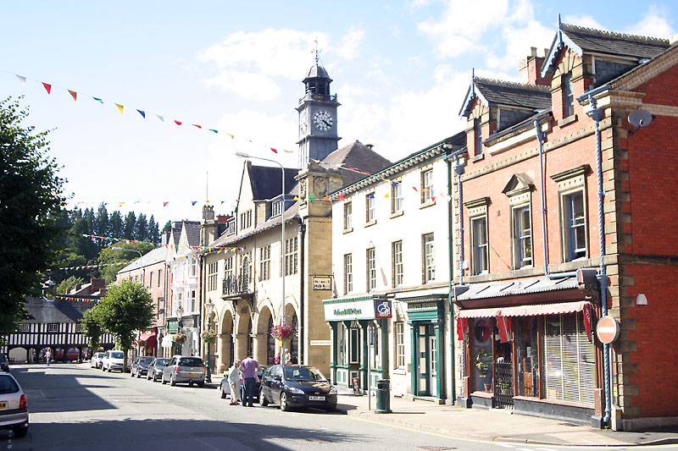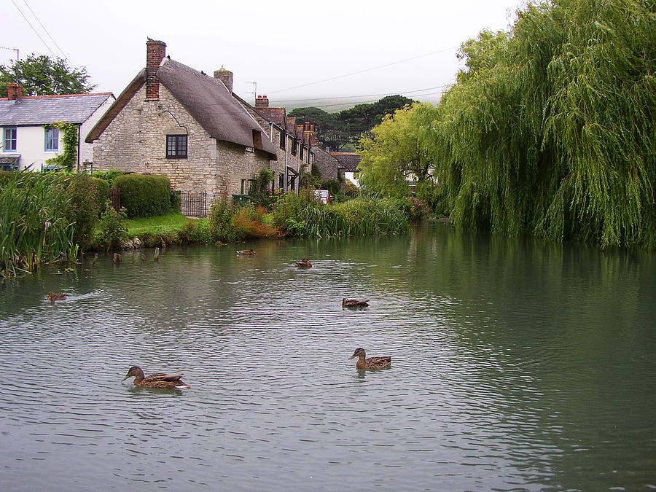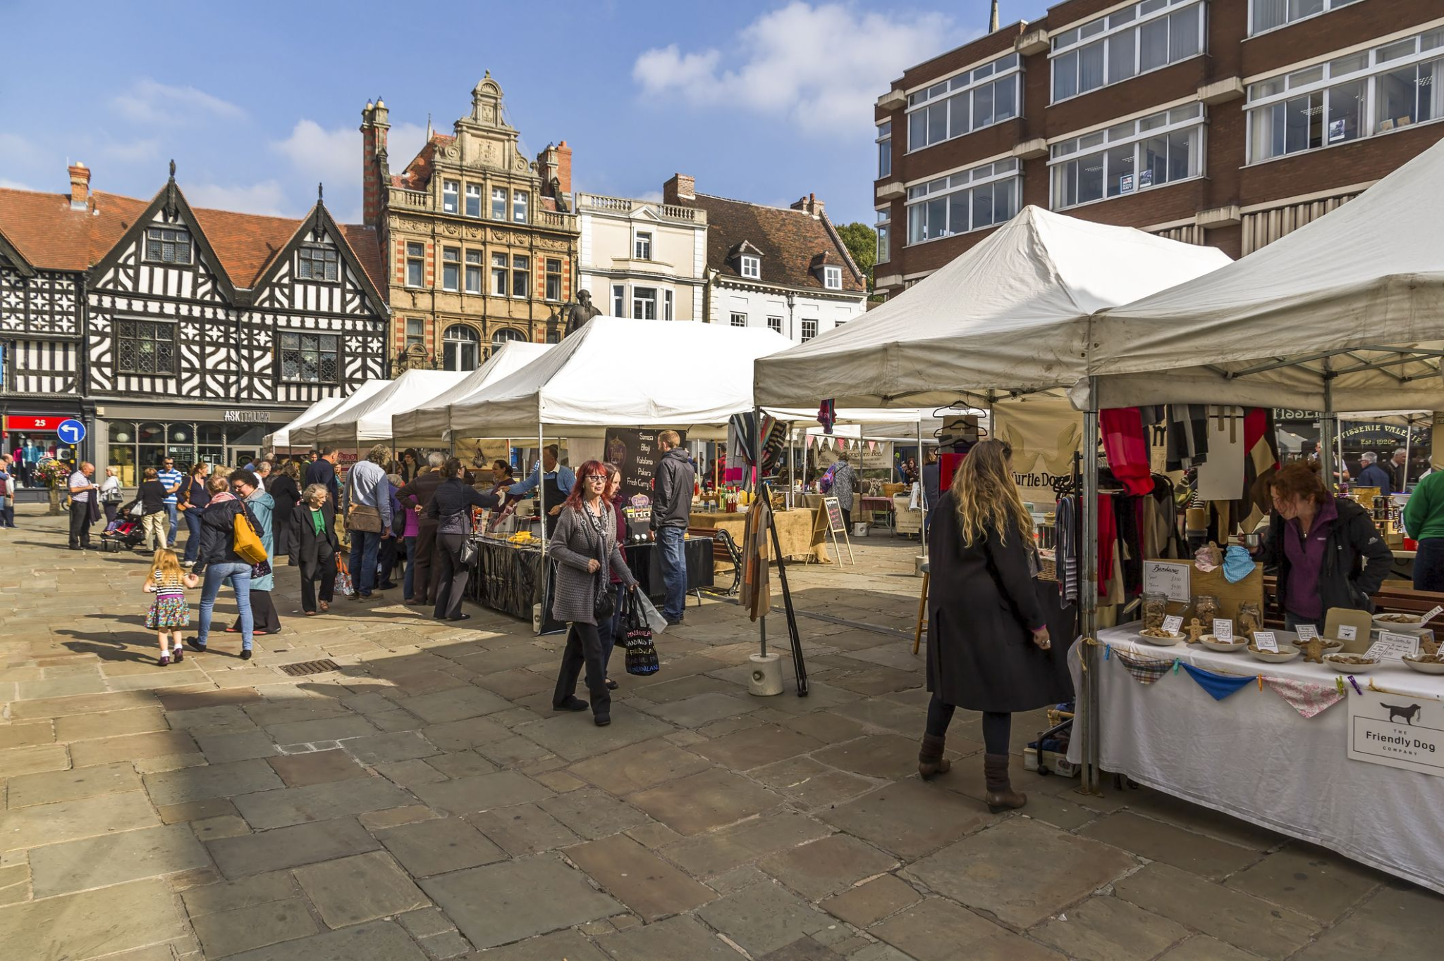

Real life inspiration - LLandidloes, Sutton Poyntz, Dorchester.

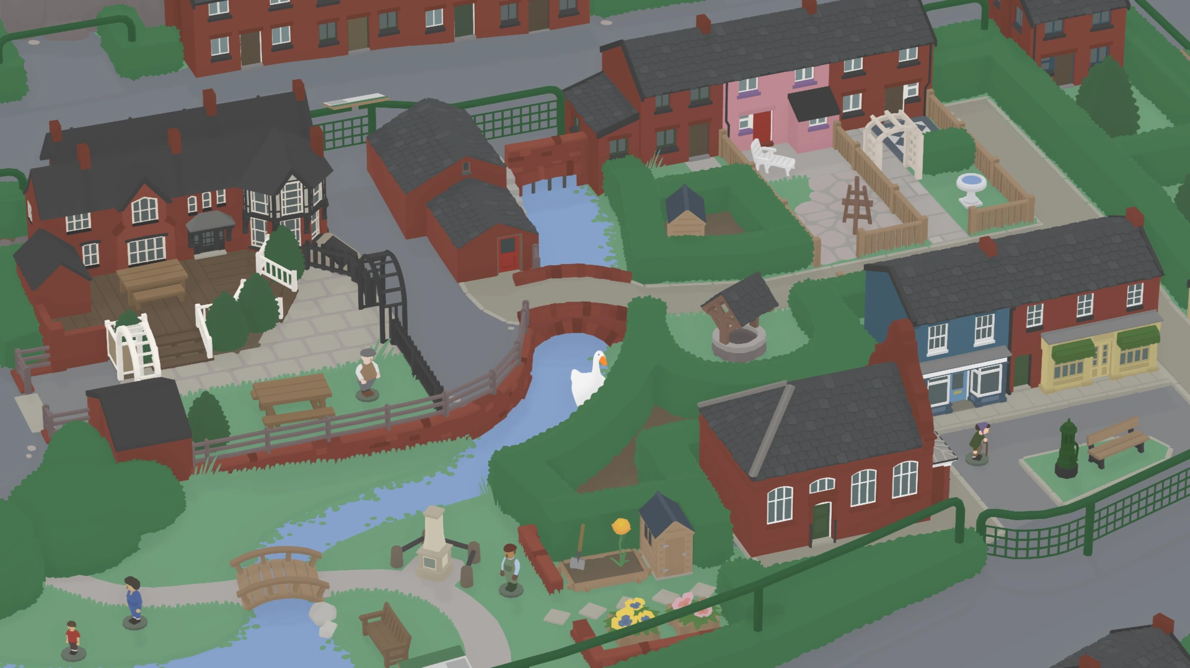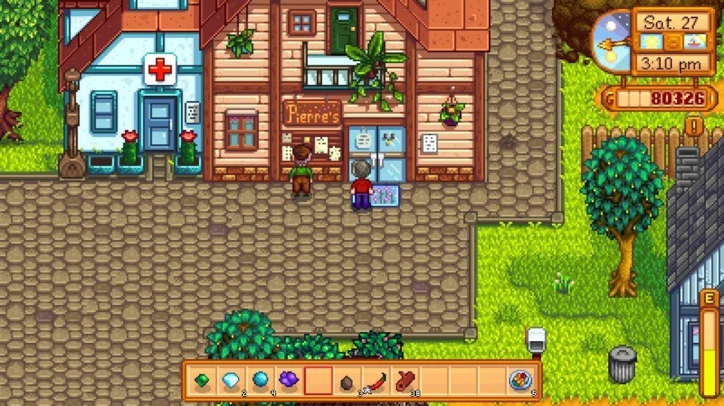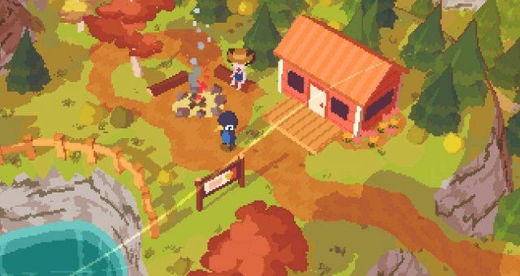

Game inspiration - Untitled Goose Game, Stardew Valley, A Short Hike.

Key points:

* Rural, countryside setting.
* Surrounded by nature - autumn.
* Selection of small independent shops required for the community to thrive.
* Central hub around duck pond with key shops, then houses and other businesses spread out into the surrounding country.

## The Map

## Theme

The main theme of the story is this: different self care practices help different people. Helping others helps you help yourself.

# Story Progression

*How does the story represent itself in changes with the game*

*This can discuss zones in relation to story beats*

*Eg first area is tutorial, x story beat is introduced x character is met*

*How does the story change as the player progresses through the game*

*What different areas are unlocked and in what order*

## Game Opening

## The main game

## Ending

## Goals

*Why are they playing? What's the point?*

*Short term and long term goals*

### Short Term Goals

* Help others around the town to make them happy

### Long Term Goals

* Learn different ways people cope with life and make themselves happy
* Understand how people rub off on one another
* Build a closer community and have fun together

## User Skills

*What kind of skills does the user need to be able to interact with the game*

*This can help to judge if any elements might be unusually hard or easy compared to the others (it can also help determine if puzzles will work on different input methods)*

*Eg drag and drop, tap screen, puzzle solving, strategy*

## 

## Game Mechanics

*As much detail as possible about all CORE mechanics*

*(I’ll do more research re: good ways to structure this at some point)*

[*http://gamestudies.org/0802/articles/sicart*](http://gamestudies.org/0802/articles/sicart)

## Items and Power Ups

*This section helps to break up the mechanics write up - while the previous section is core “Innate” abilities and game elements, this section can be used to describe additional abilities or temporary changes to mechanics*

## Progression and Challenge

*Consider how the difficulty will change as the player progresses and how they will be equipped to deal with it*

*How will the player progress? Unlocks? Door keys?*

## Losing

*How do you lose? CAN you lose? I want the player to experience it all.*

*Health? Time?*

# Art Style

### Overall

This section describes the overall art direction of the game.

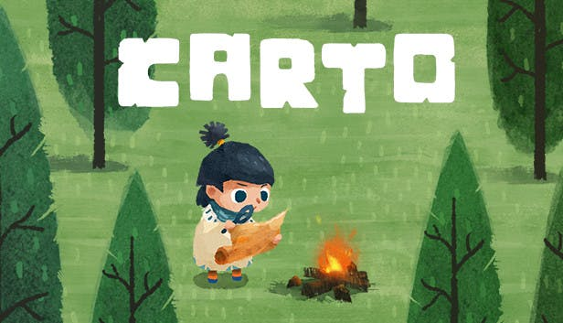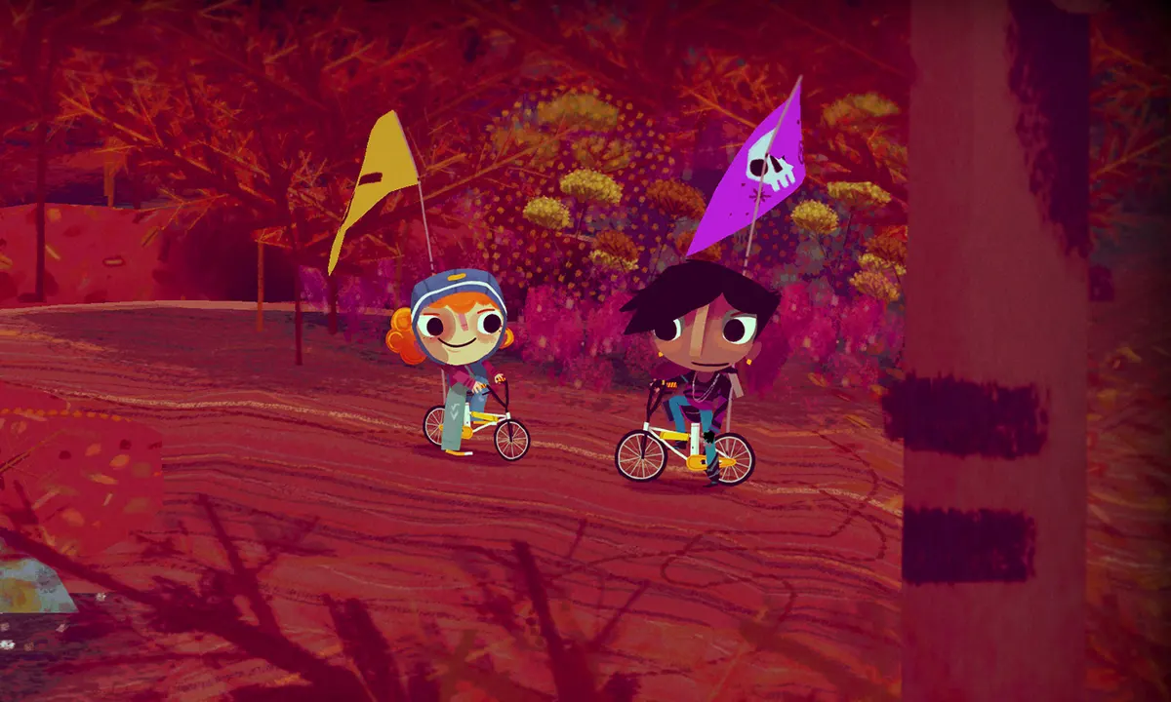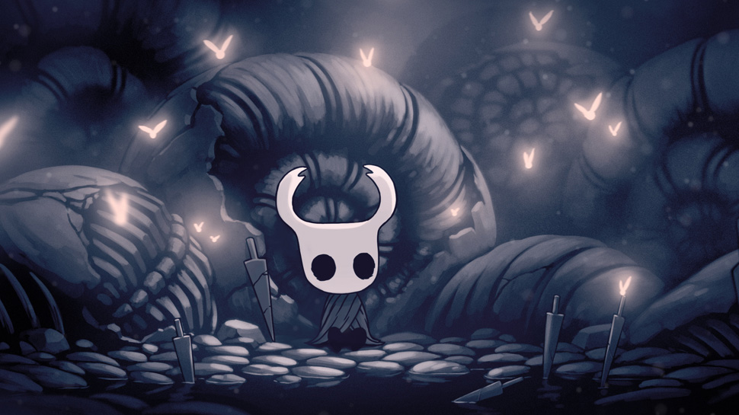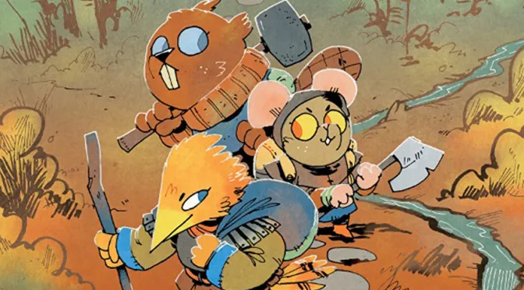

Examples, from left to right: Carto, Knights and Bikes, Hollow Knight, Root

* Two-dimensional
* Flat, simple shapes but with some painterly textures
* Organic, hand-drawn lines and forms
* Cosy colour palette

### Characters

This section describes the design of the characters in the game.

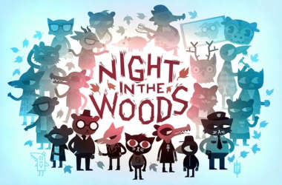

Example: Night in the Woods

### Environment

This section describes the design of the environment and backgrounds of the game.

Example:

### User Interface

This section describes the design of the UI of the game - this includes, windows, icons, and interactive elements.

# Music and Sounds

*What kind of music?*

*What kind of sounds?*

*Emotional points?*

# Technical Description

# Marketing

## Demographics

## Platforms and Monetisation

## Localisation

# Other Ideas

Misc ideas